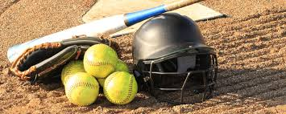
All OLV Girls in Grades 6-8
are invited to play
SOFTBALL
This year Saint Joseph’s Catholic Academy added Girls Softball to their growing list of sports teams, and OLV alumni are playing pivotal roles and having fun on this inaugural SJCA Girls Softball team. Many SJCA team members have told Coach Myers that they wish that they could’ve learned more about softball while they were at OLV.

So, with this in mind, the SJCA girls team and Head Coach Myers would like to host series of fun softball skills clinics for girls at OLV. Girls of all skill and experience levels would be welcome! If there enough OLV girls interested, they would also like to create a club team to play over the summer.

Coach Myers is starting to plan these softball opportunities now and looking to gauge interest.
To let Coach Myers know your student is interested in softball and/or to receive more information about the softball clinics and/or team play, contact Coach Myers at (814) 762-4394 (text) or softball@stjoeacad.org

More information about SJCA Sports can be found at https://sjcasports.org/ or by contacting
Dr. Justin Rodkey, SJCA Athletic Director at jrodkey@sjcacademy.org. Go Wolfpack!

